Disburser is a web-based tool for submitting and managing disbursement requests for specimen and/or data from biorepositories across Robert H. Lurie Comprehensive Cancer Center of Northwestern University.

The application allows a user to:

* View in a centralized location available specimen and data biorepositories.
* See an overview of the contents of each specimen and data biorepository.
* Submit disbursement requests to specimen and data biorepositories.
* Track the approval and fulfillment of disbursement requests.
* Log in with a Northwestern NetID or setup an account with an email address.

The application allows a committee member to:

* Vote and comment on disbursement requests as a biorepository committee member.

The application allows a repository administrator to:

* Manage the setup of a biorepository.
* Manage the ‘Status’, ‘Data Status’ and ‘Specimen Status’ of disbursement requests.

The application allows a biorepository data coordinator to:

* Manage the ‘Data Status’ of disbursement requests.

The application allows a biorepository specimen coordinator:

* Manage the ‘Specimen Status’ of disbursement requests.

This user guide is meant for Disburser biorepository administrators, biorepository data coordinators and biorepository specimen coordinators. Other user guides cover using Disburser as a submitter/investigator and a biorepository committee member.

**Access**

Permission to use Disburser is available to all owners of a Northwestern NetID and password. Alternatively, non-Northwestern individuals can setup an account with an email address and a password of their choice.

Disburser is located at the following URL:

<https://disburser.cancer.northwestern.edu/>

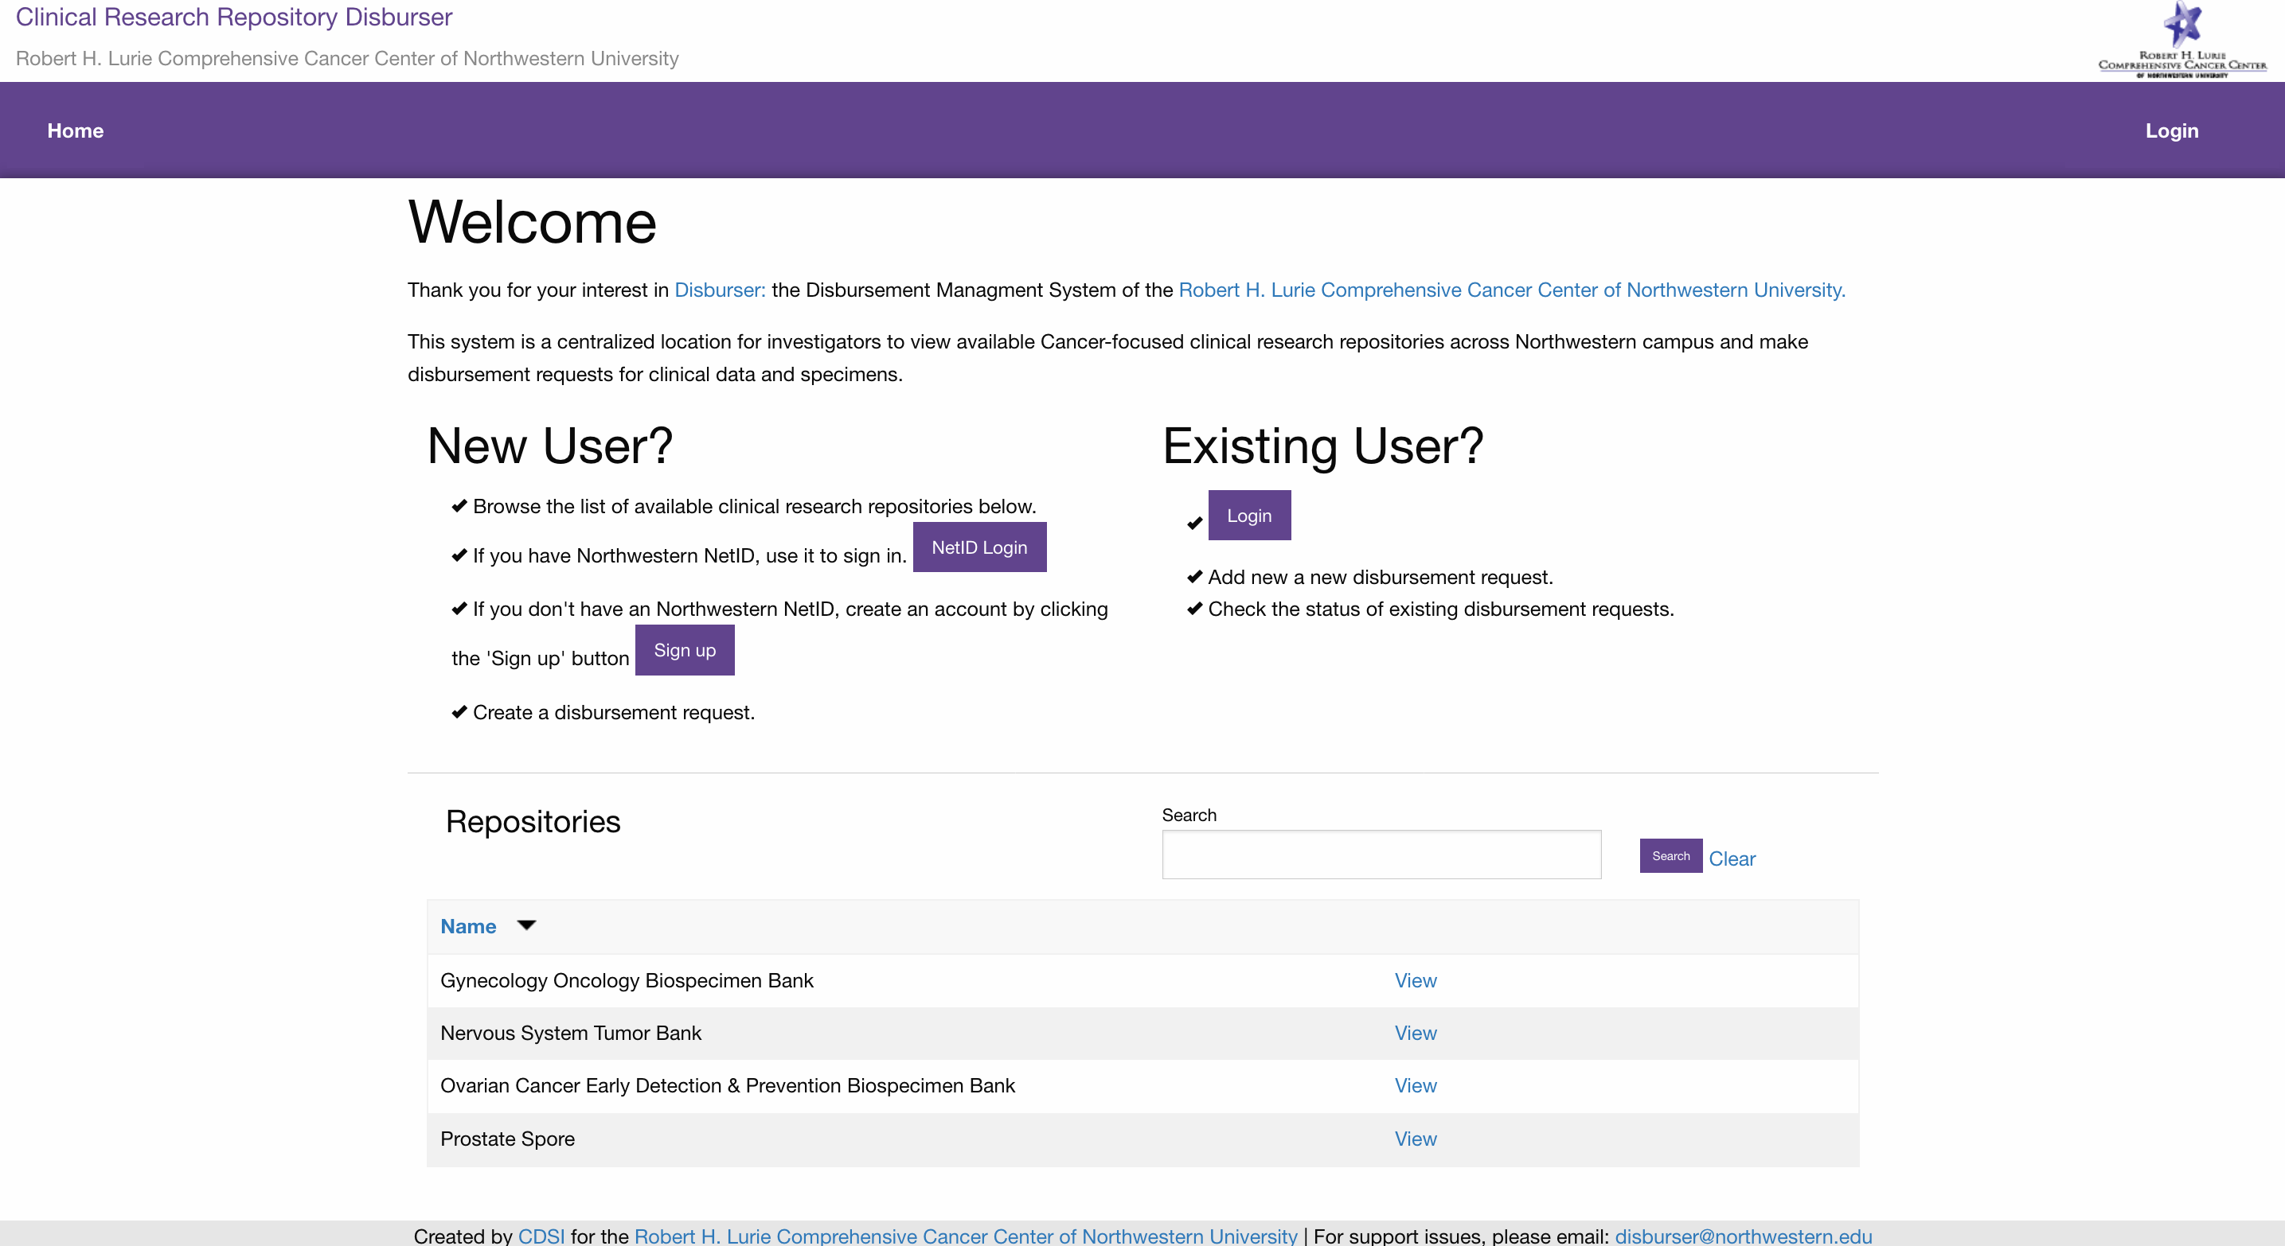

**Login with a Northwestern NetID**

Click the ‘Login’ link in the upper right corner. You will be asked if you have a Northwestern NetID.

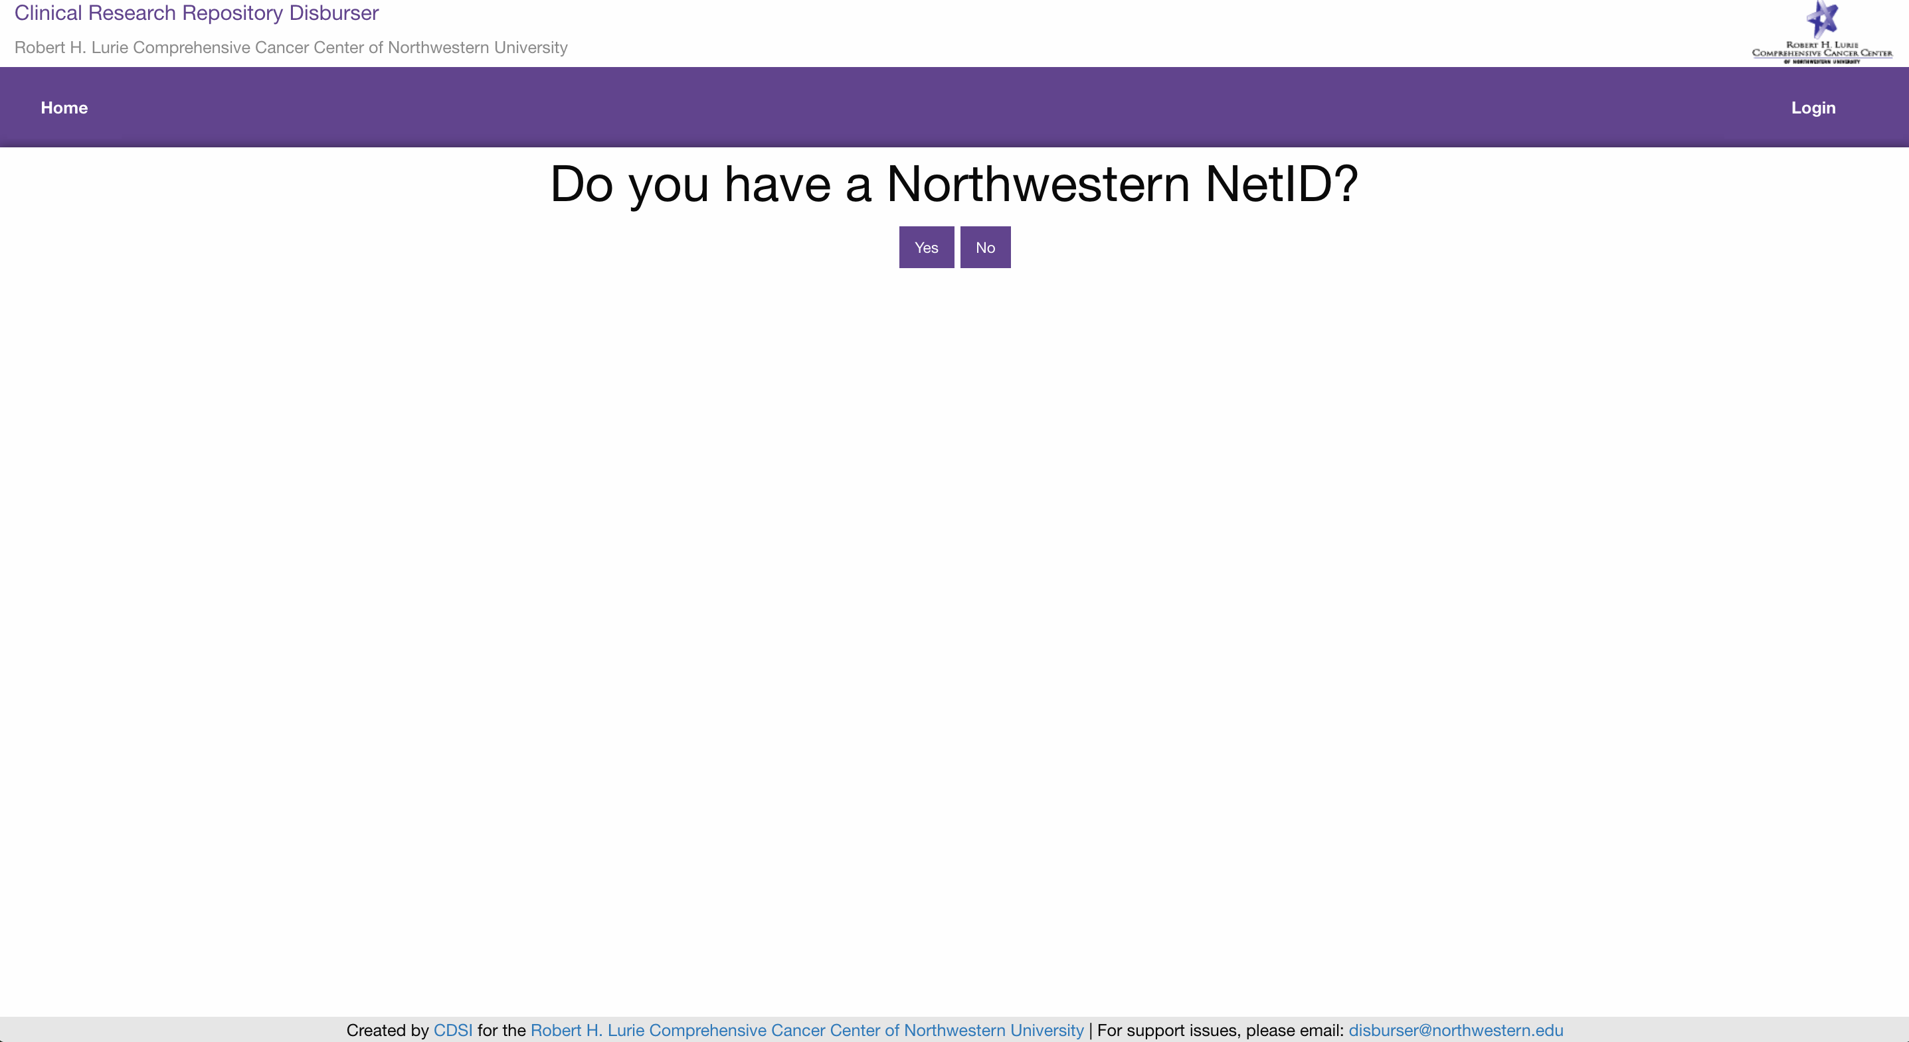

If you have a Northwestern NetID, click the ‘Yes’ button. You will be asked to login with your NetID and password.

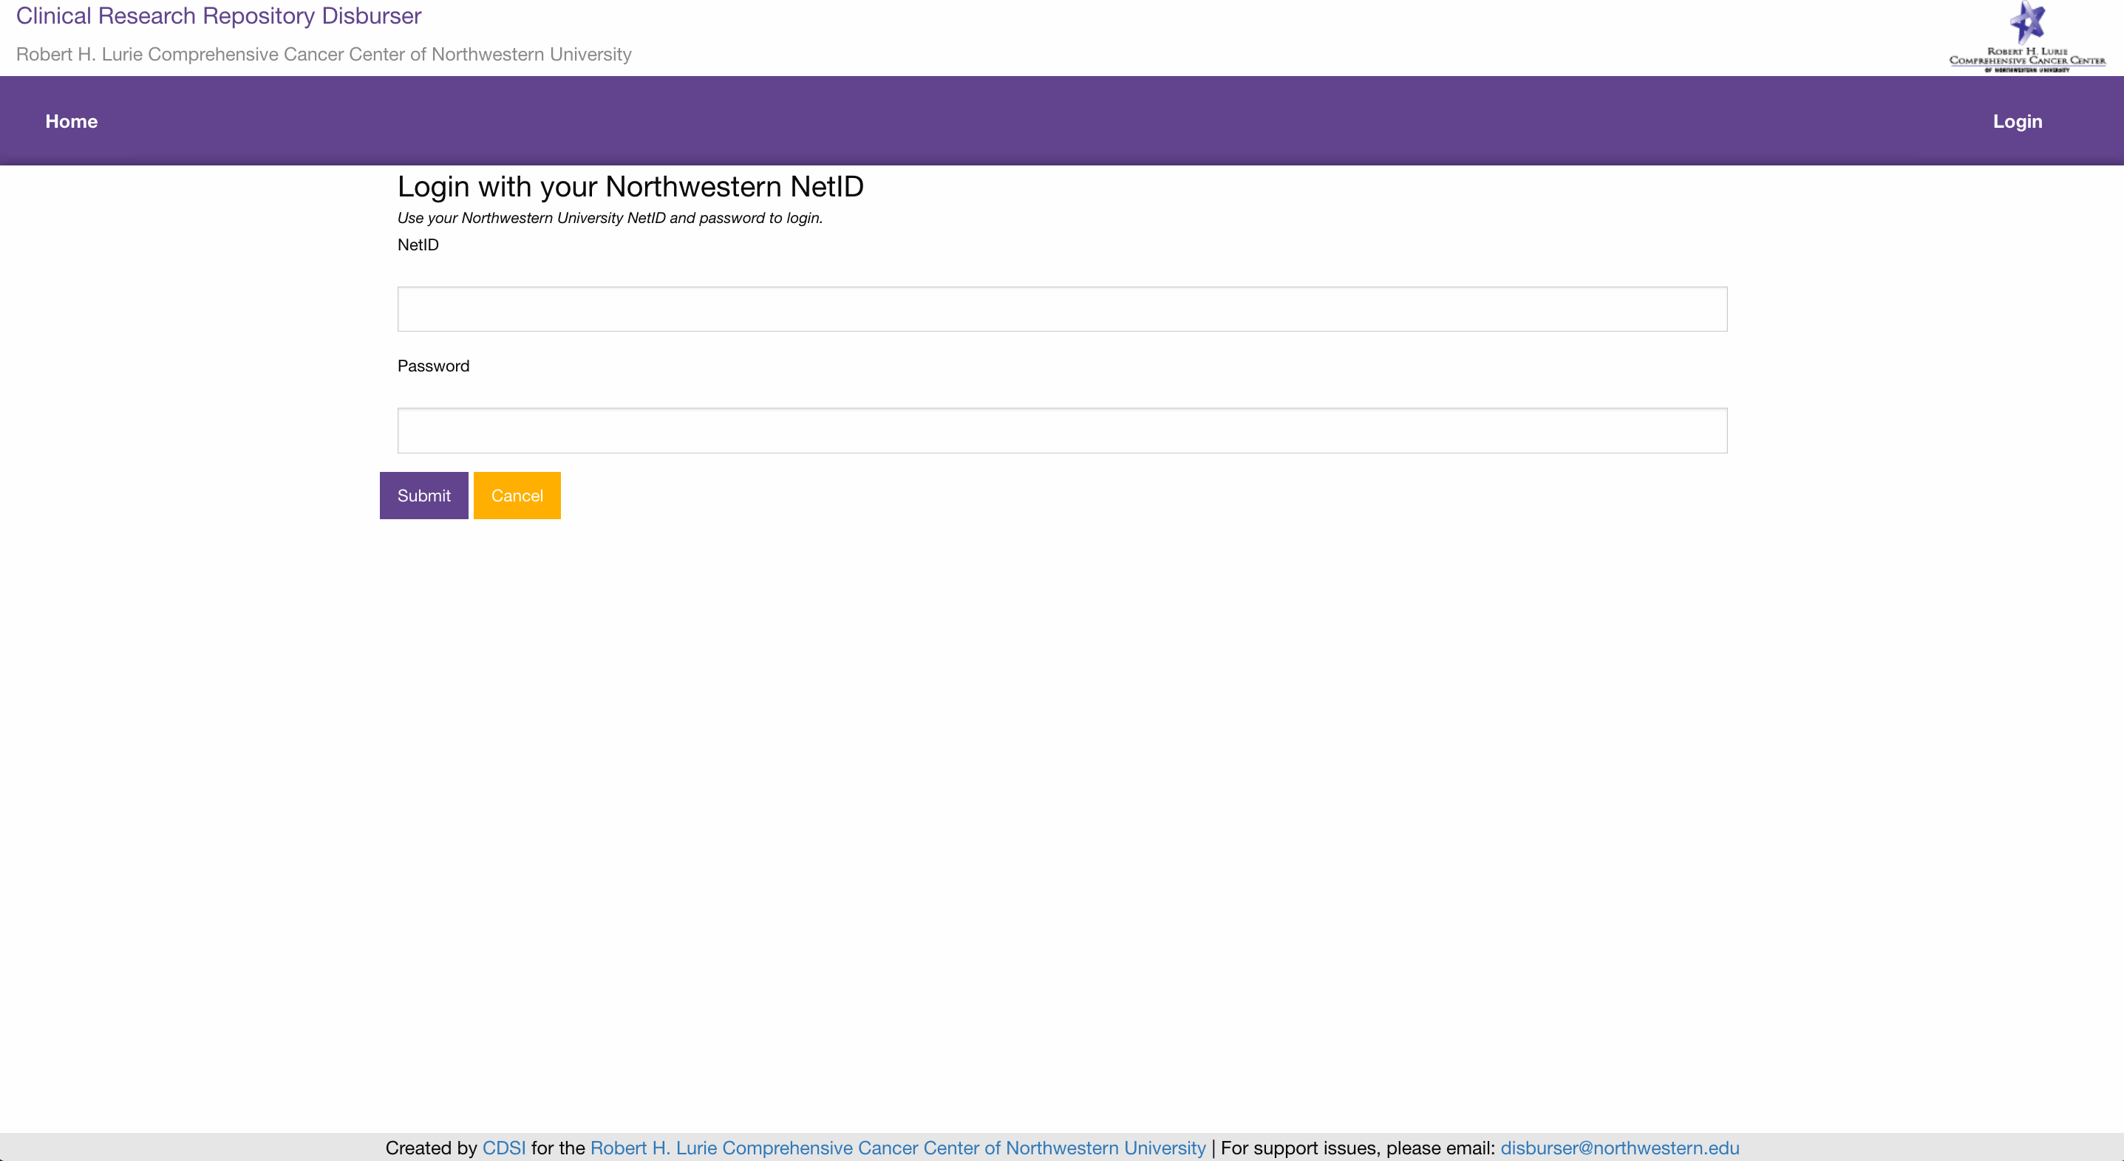

**Login with an Email Address**

If you do not have a Northwestern NetID, you can setup a Disburser account with an email address and a password of your choice. Click the ‘Login’ link in the upper right corner. You will be asked if you have a Northwestern NetID. If you do not have a Northwestern NetID, click the ‘No’ button. You will be asked to login with your Email and a password of your choice.

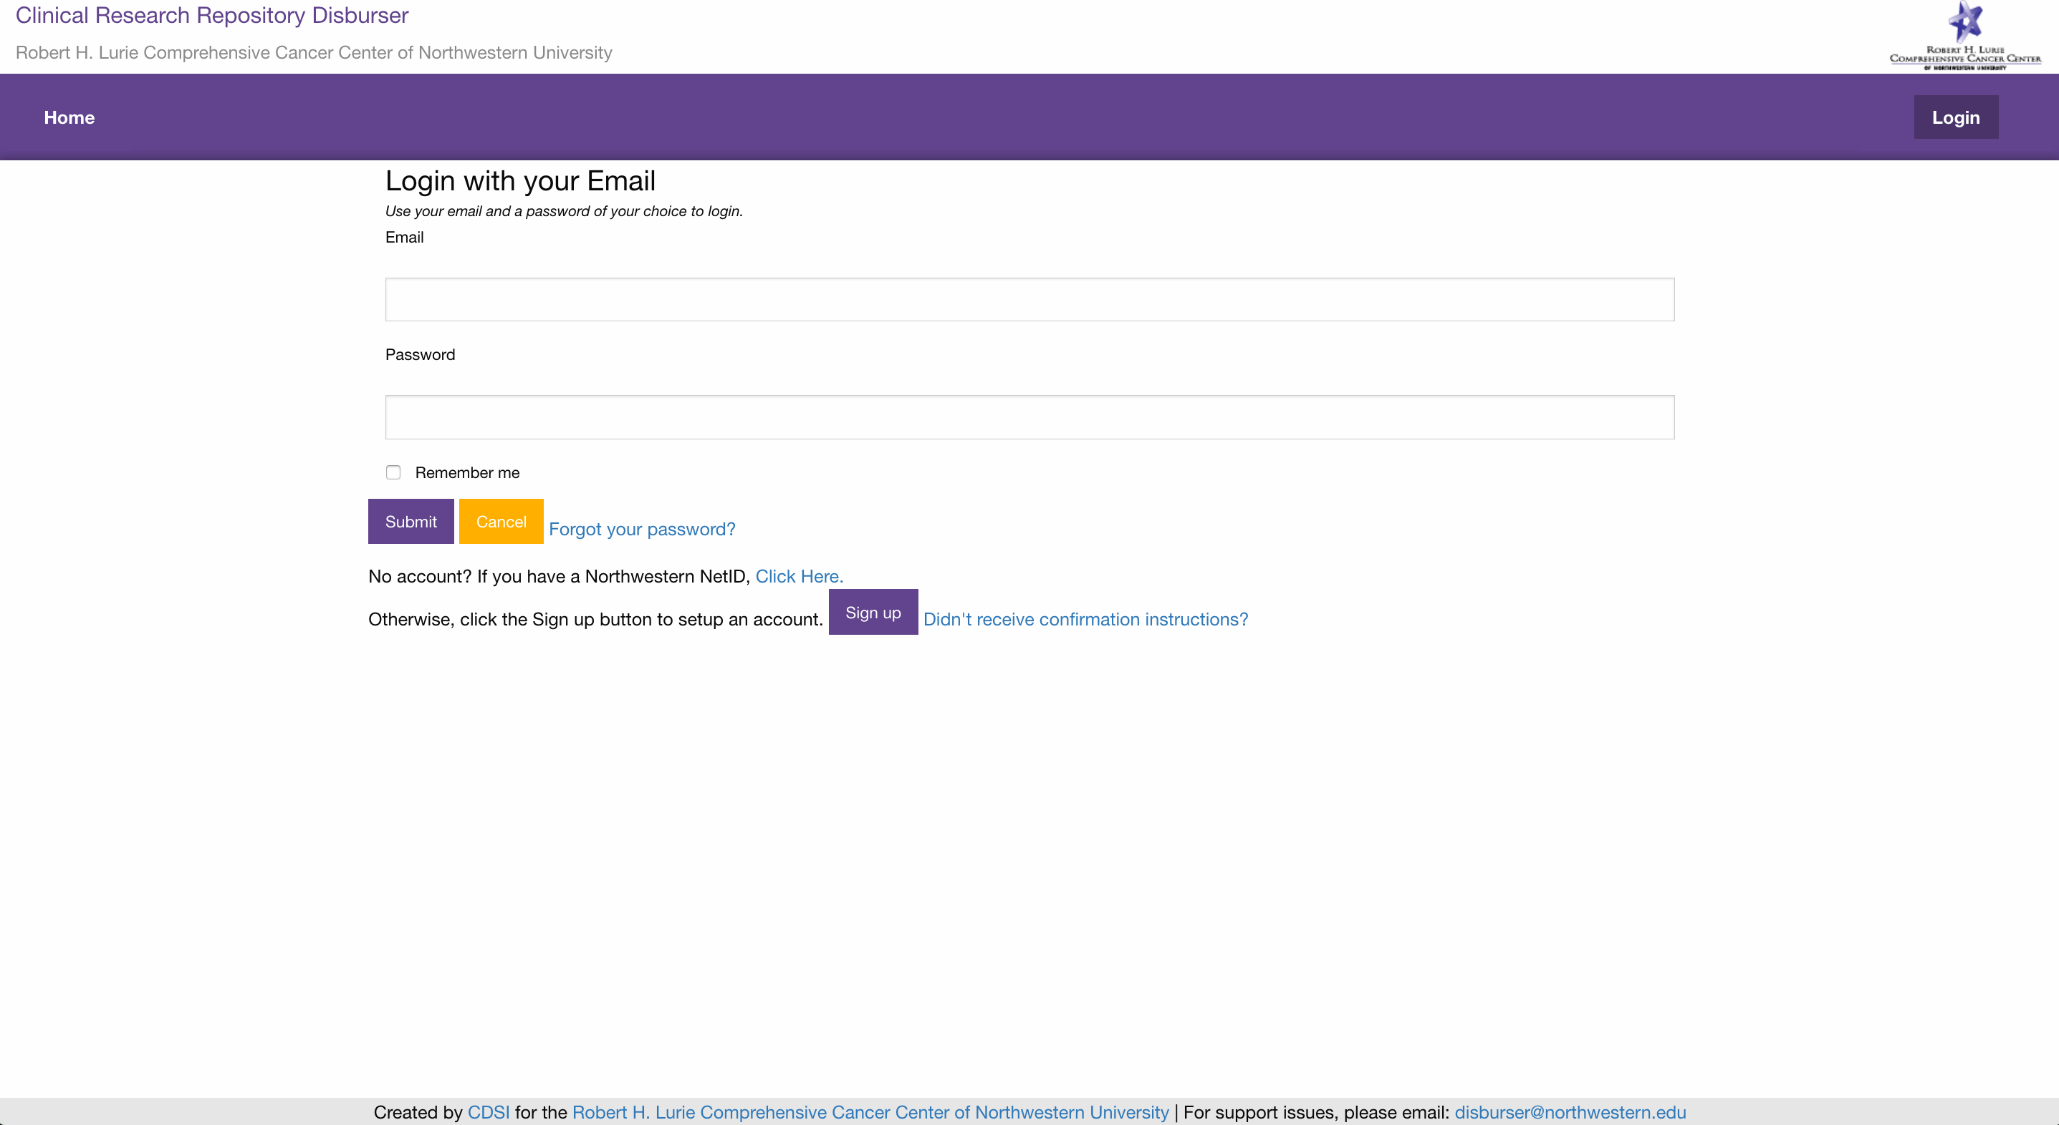

If you do not have a Disburser account setup, click the ‘Sign up’ button. You will be prompted to enter a ‘First Name’, ‘Last Name’, ‘Email’ and ‘Password’.

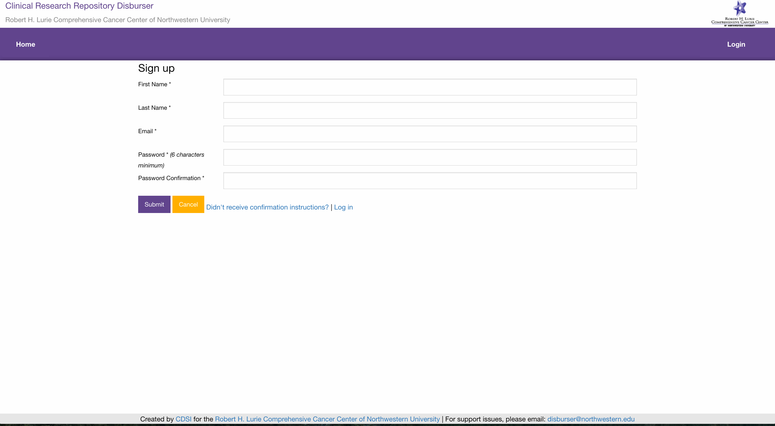

An email message with a confirmation link will be sent to your email address. Follow the link to activate your account.

**Managing the setup of a biorepository**

A biorepository administrator will have a ‘Repositories’ menu item. The ‘Repositories’ page lists all the biorepositories the user administers.

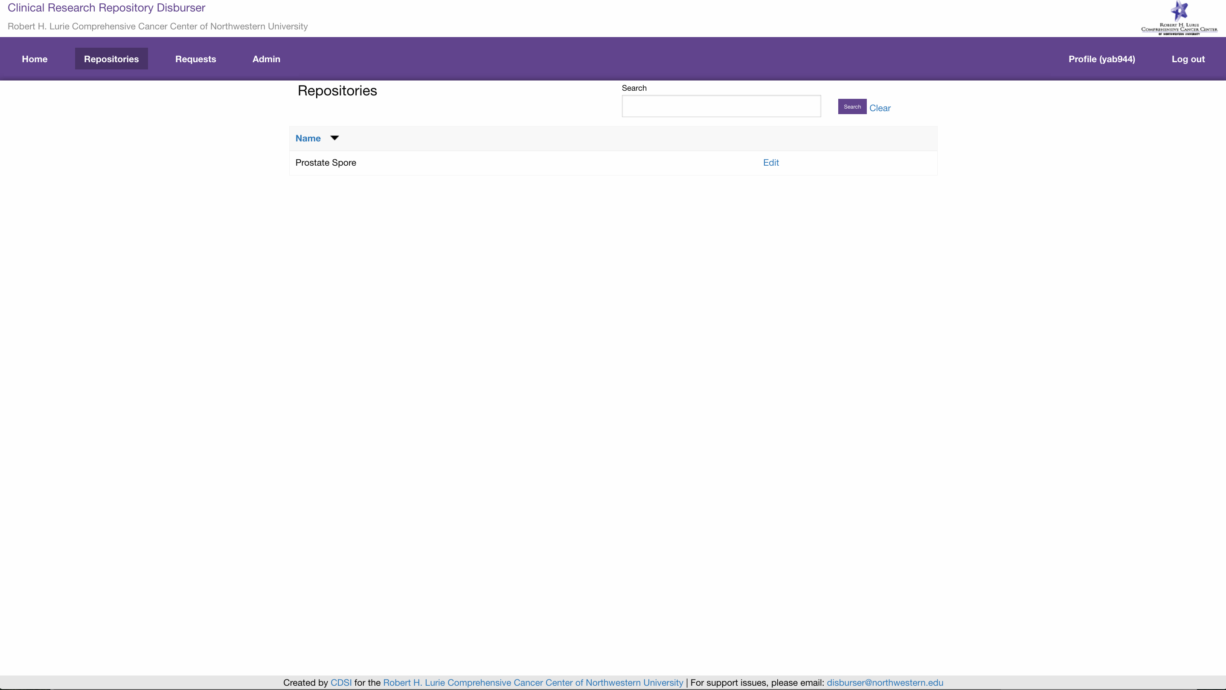

Click the ‘Edit’ link for the repository you would like to administer. This will bring you to the ‘Details’ tab of the biorepository.

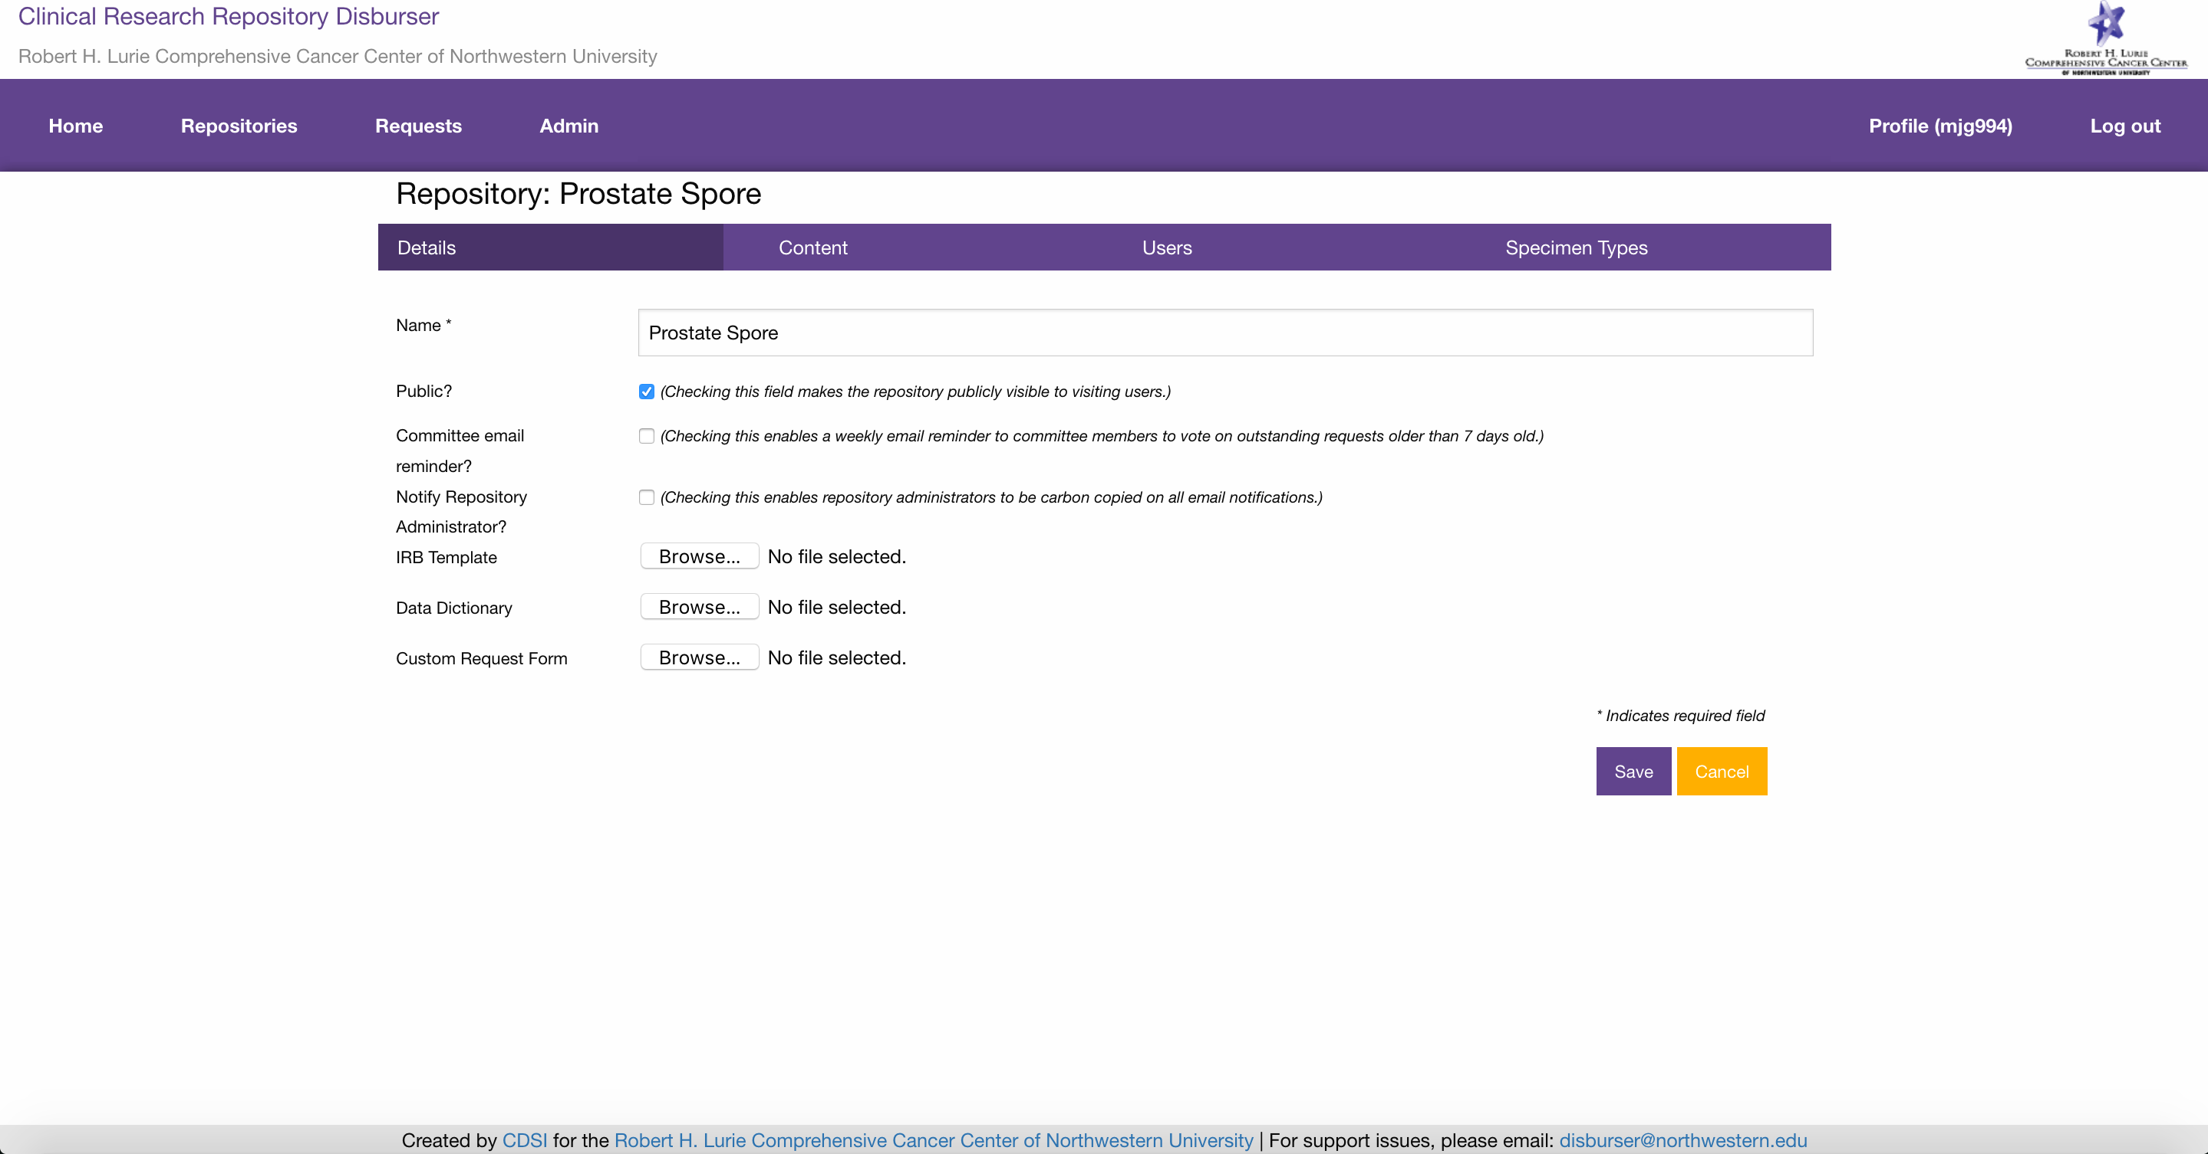

The ‘Details’ tab allows you to set the following fields:

* ‘Name’: the name of the biorepository.
* ‘Public?’: Boolean flag marking whether a biorepository should be displayed on the public home page of Disburser.
* ‘Committee email reminder?’: Boolean flag marking whether the system should automatically send out a weekly email reminder too all committee members to vote on all disbursement requests with a ‘Status’ of ‘committee review’ that the committee member has not voted on.
* ‘Notify Repository Administrator?’: Boolean flag marking whether the system should carbon copy repository administrators on all email notifications.
* ‘IRB Template’: Upload a document that provides guidance on how to prepare an IRB submission for a research project that request specimens or data from the biorepository. This document will be linked from the biorepository home page.
* ‘Data Dictionary’: Upload a document that provides a detailed description of the data elements available to be disbursed from the biorepository.
* ‘Custom Request Form’: Upload a document that provides an alternative mechanism for the investigator/submitter to detail a disbursement request. Normally, these details can be specified within the Disburser system itself. Only appropriate for biorepositories reliant on a legacy request form.

Click the ‘Content’ tab.

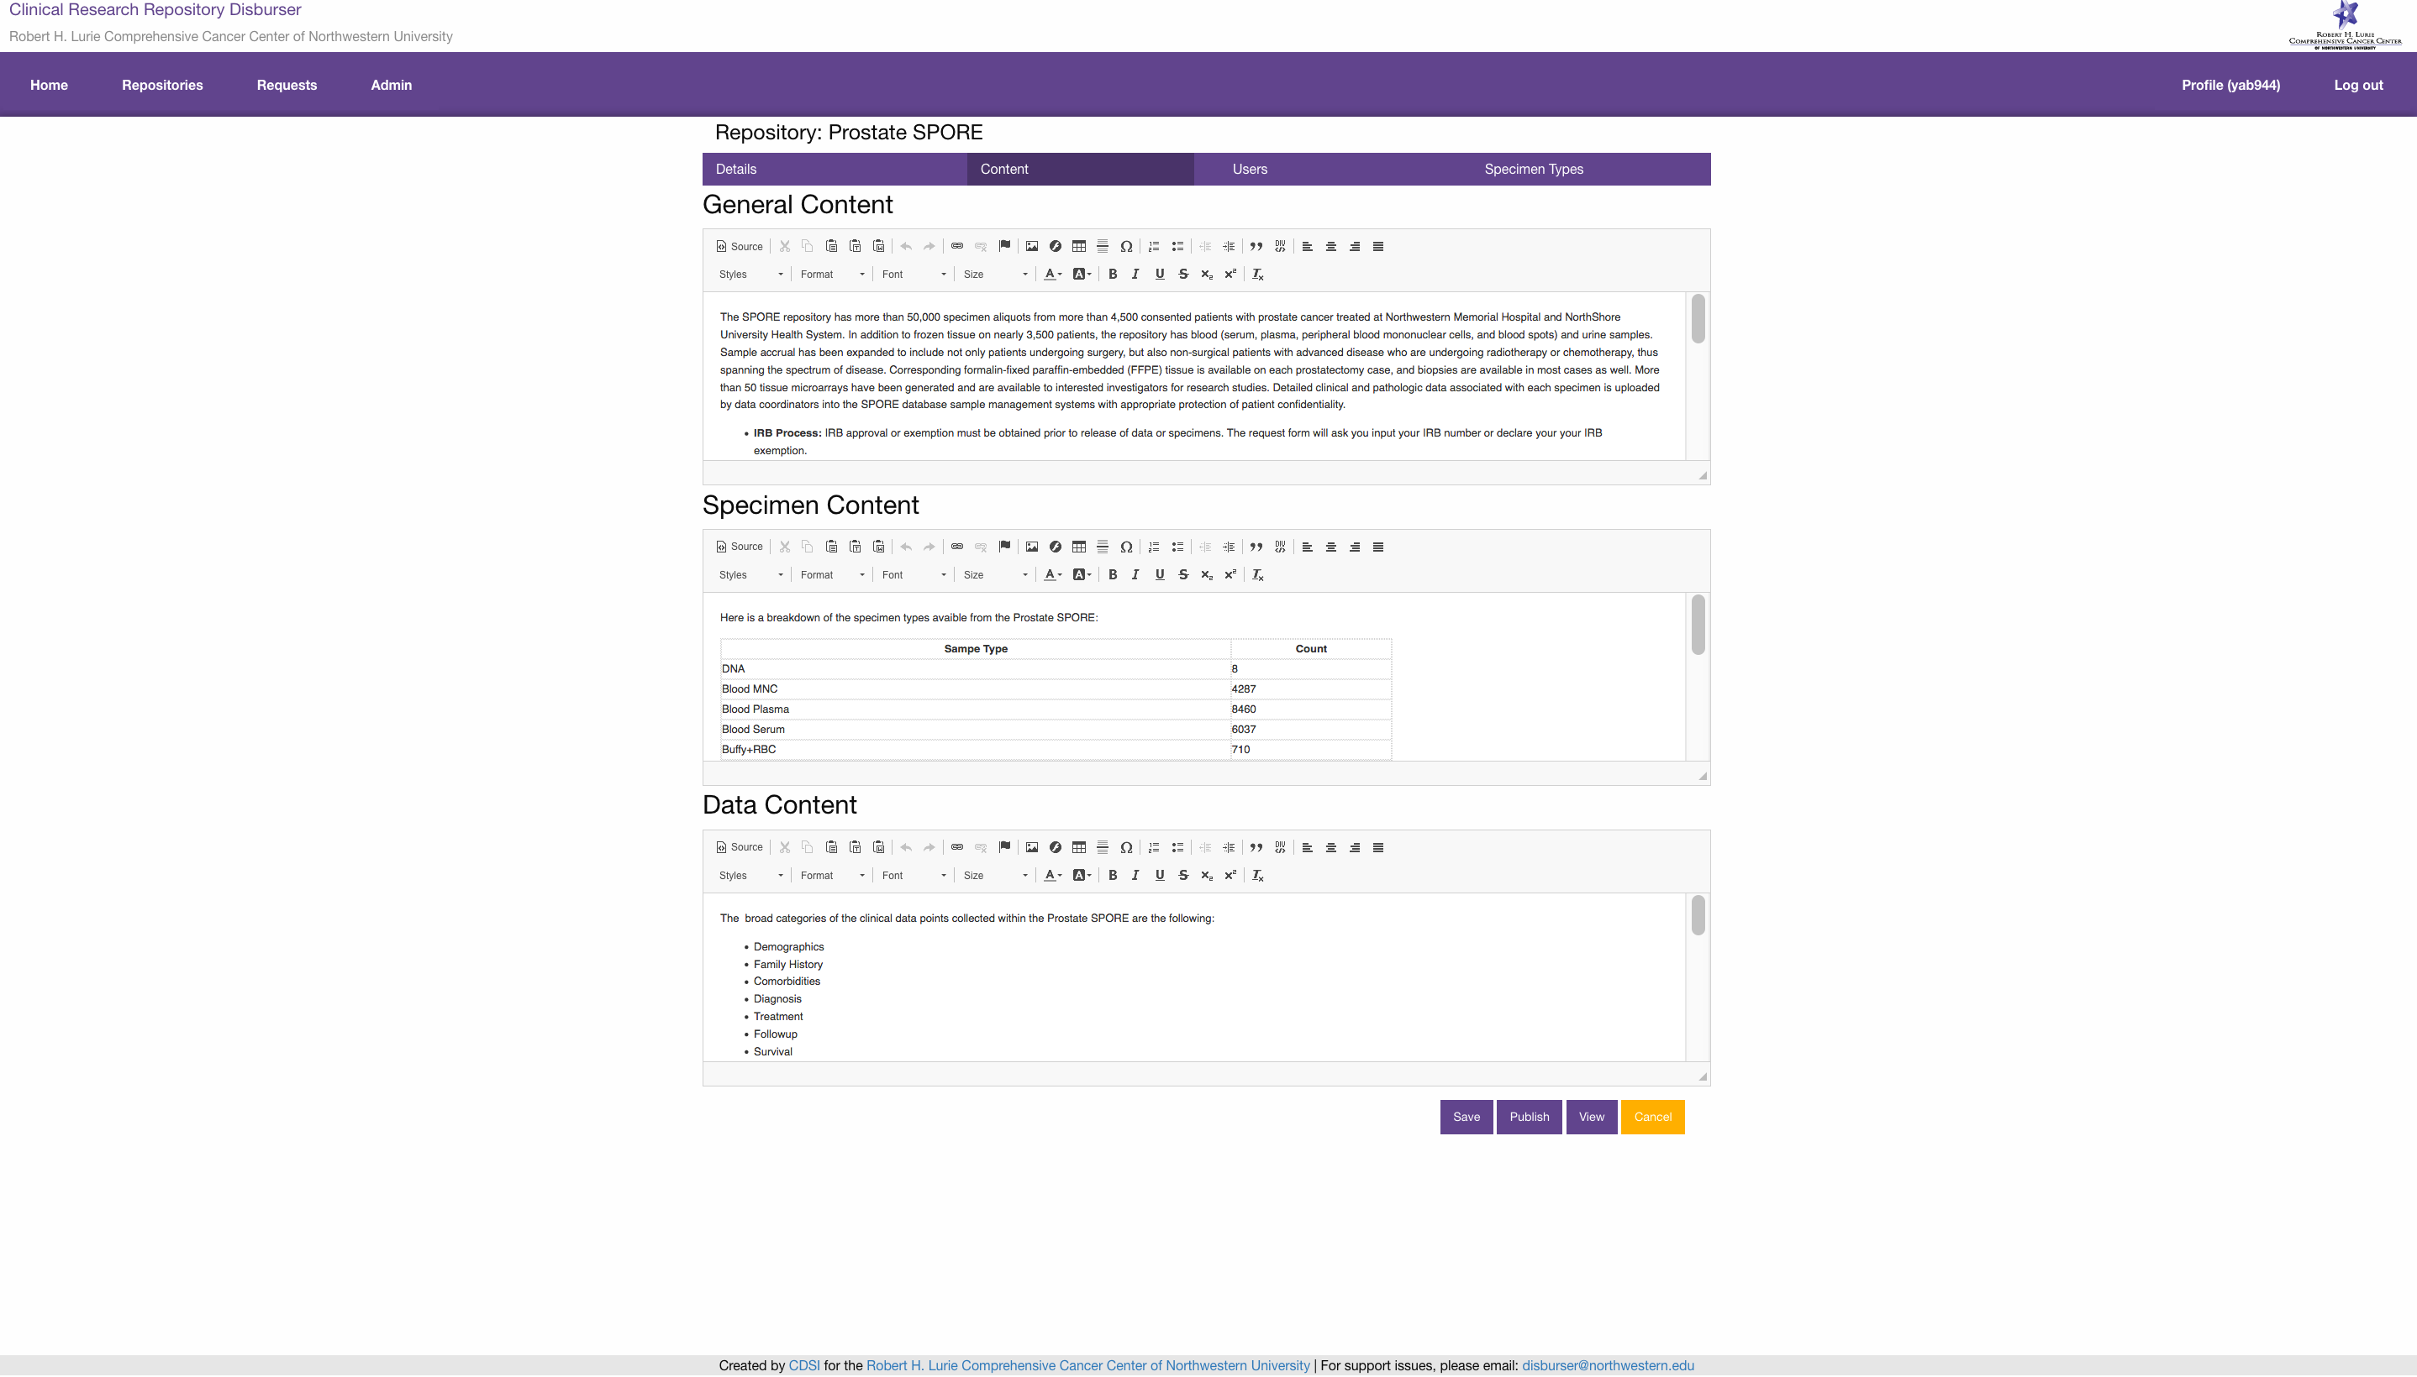

The ‘Content’ tab allows you to set the following fields:

* ‘General Content’: A WYSIWYG HTML editor that allows you to specify an overall description of the biorepository. Its purpose, operation, governance and IRB process. This content will be displayed on the biorepository home page.
* ‘Specimen Content’: A WYSIWYG HTML editor that allows you to specify a general description of the specimens collected for the clinical research repository. If desired, you can display a table of counts of specimens available of each specimen type. This content will be displayed on the biorepository home page.
* ‘Data Content’: A WYSIWYG HTML editor that allows you to specify a general description of the data collected for the biorepository. If desired, you can display a table of counts of data available broken down by relevant data points. This content will be displayed on the biorepository home page.

Clicking the ‘Save’ button saves the content in an unpublished sate. Clicking ‘Publish’ will publish button makes the unsaved drafts publicly viewable. The ‘Publish’ but is only available when draft versions are currently unpublished.

Click the ‘Users’ tab.

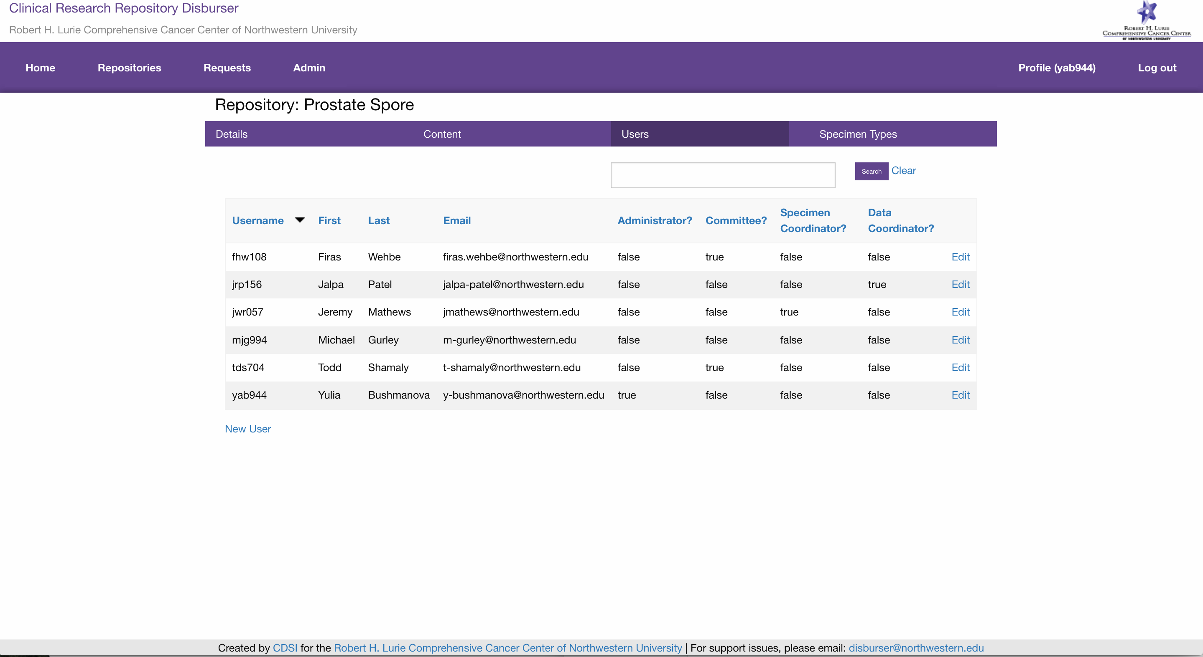

The ‘Users’ tab allows you to add and edit users’ roles within the biorepository. You do not need to add users for investigators to submit disbursement requests to the biorepository.

Click the ‘New User’ link.

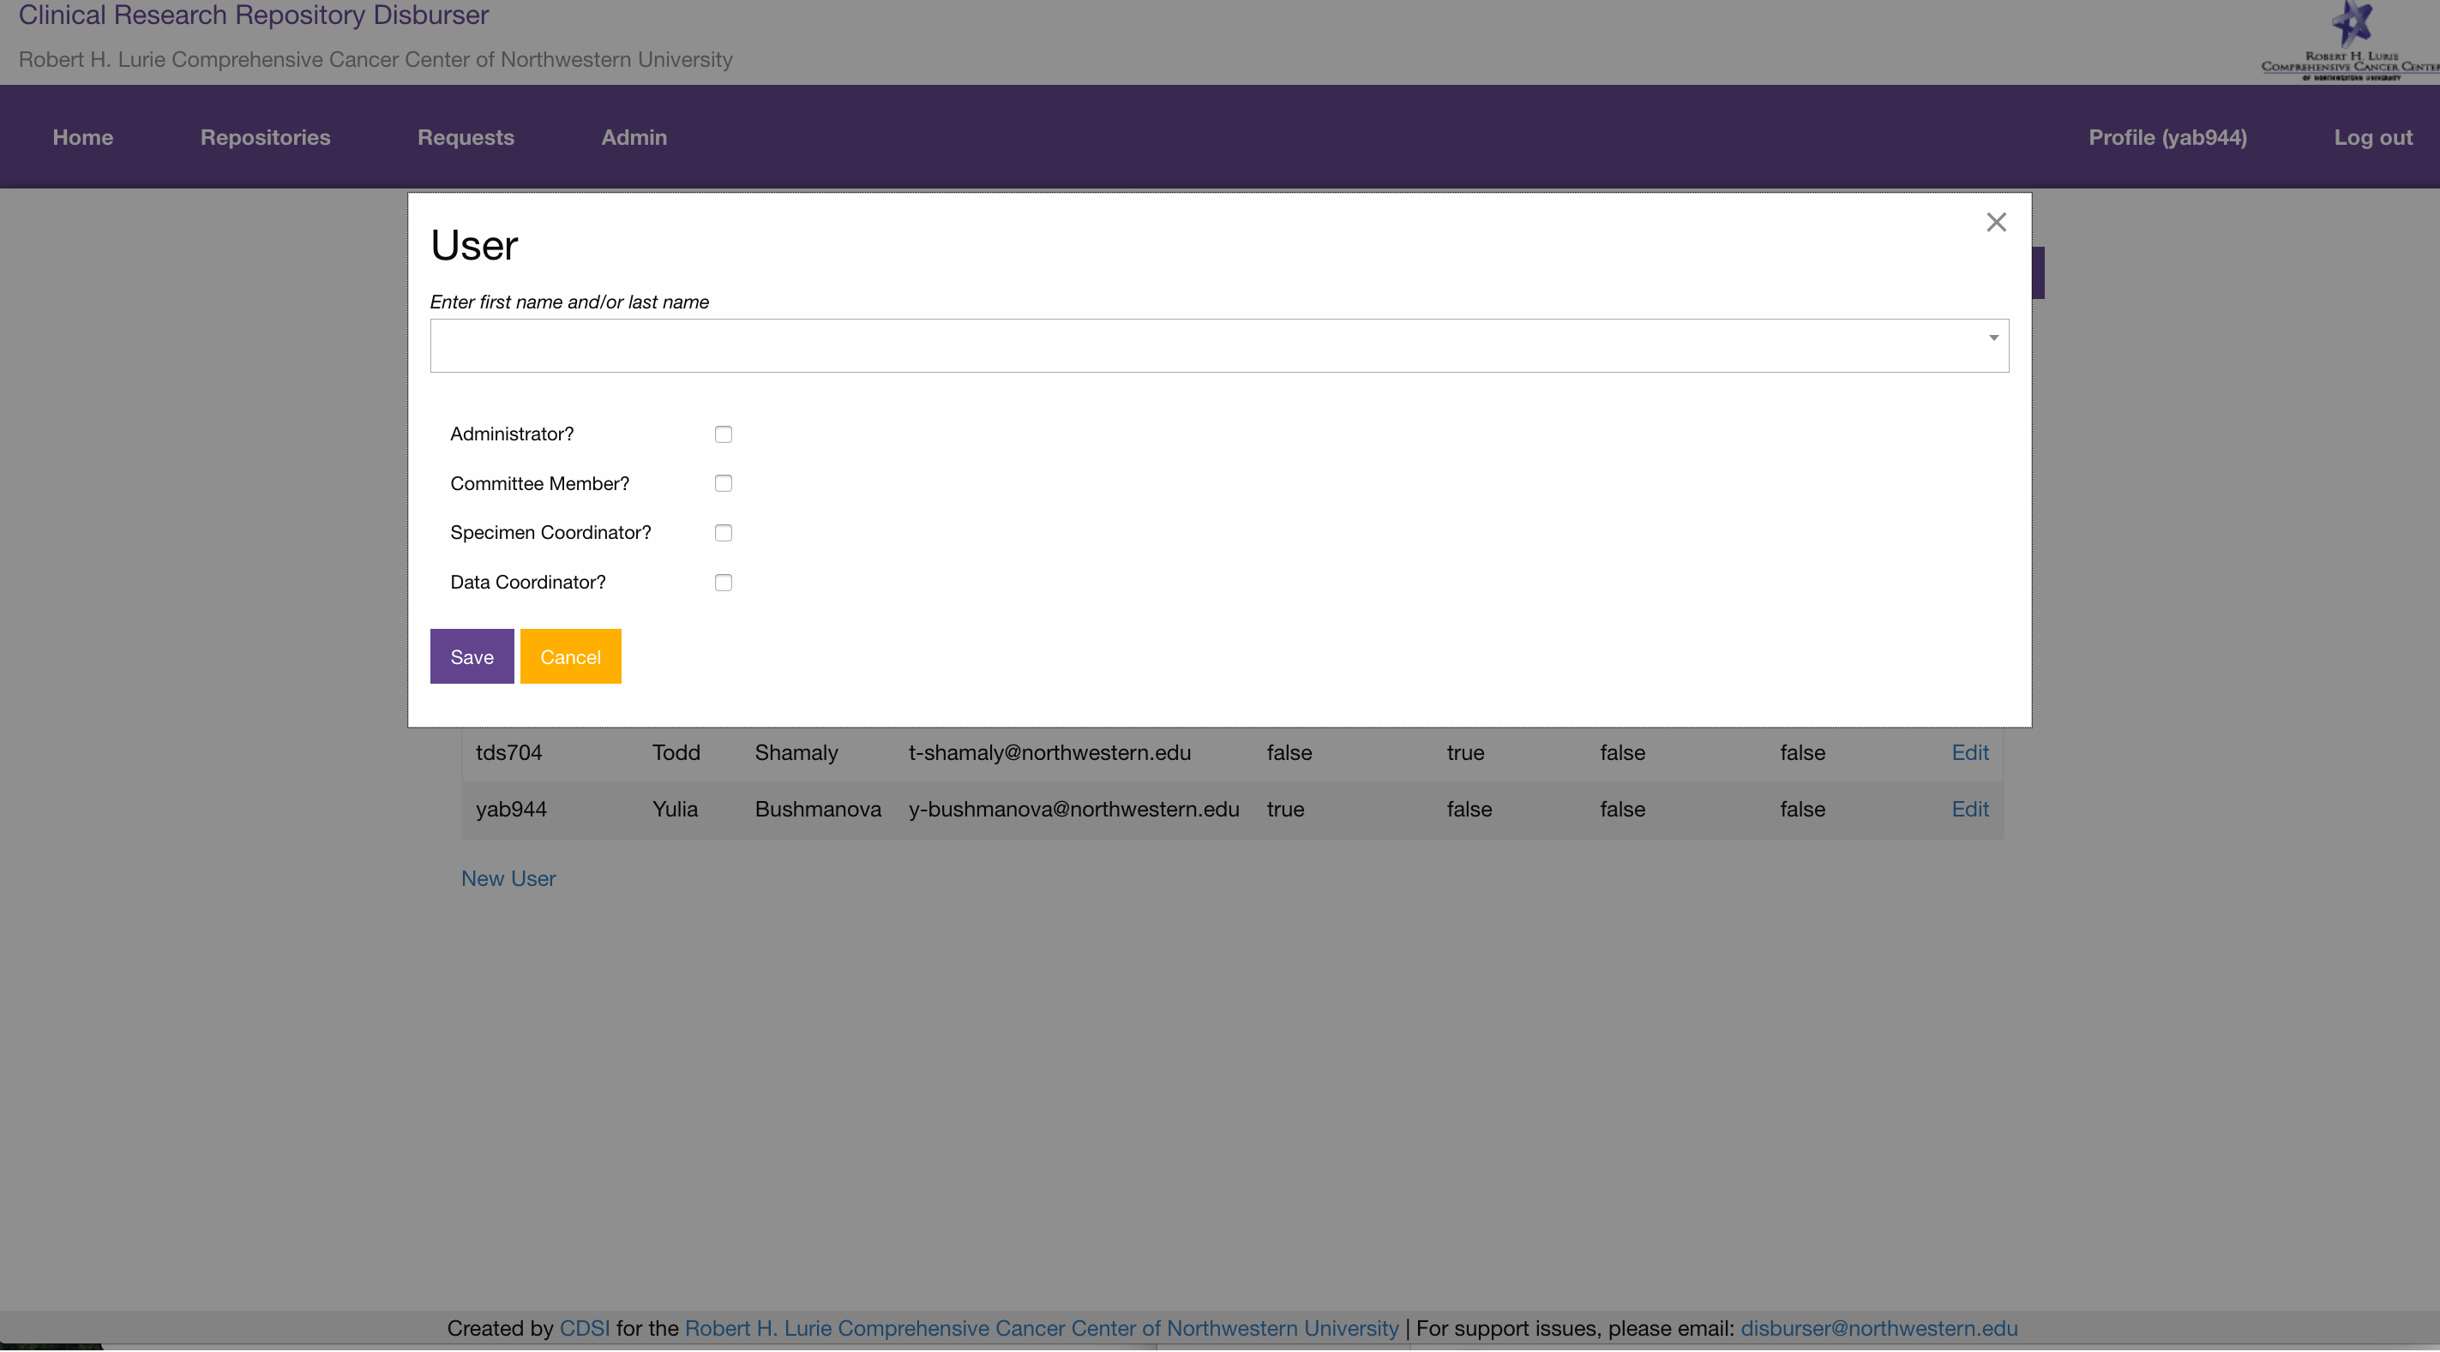

Type in the first name or last name of the user you would like to add to the biorepository. This will search Northwestern’s LDAP directory as well as any locally setup external users. You can specify that the user has any of the 4 following rules:

* ‘Administrator?’: Boolean flag marking whether the user should be granted the privileges of being an administrator of the biorepository.
* ‘Committee Member?’: Boolean flag marking whether the user should be granted the privileges of being a committee member of the biorepository. Committee members are responsible for voting on and commenting on disbursement requests.
* ‘Specimen Coordinator?’: Boolean flag marking whether the user should be granted the privileges of being a specimen coordinator of the biorepository. Specimen coordinators are responsible for updating the ‘Specimen Status’ of disbursement requests.
* ‘Data Coordinator?’: Boolean flag marking whether the user should be granted the privileges of being a data coordinator of the biorepository. Data coordinators are responsible for updating the ‘Data Status’ of disbursement requests.

Click the ‘Specimen Types’ tab.

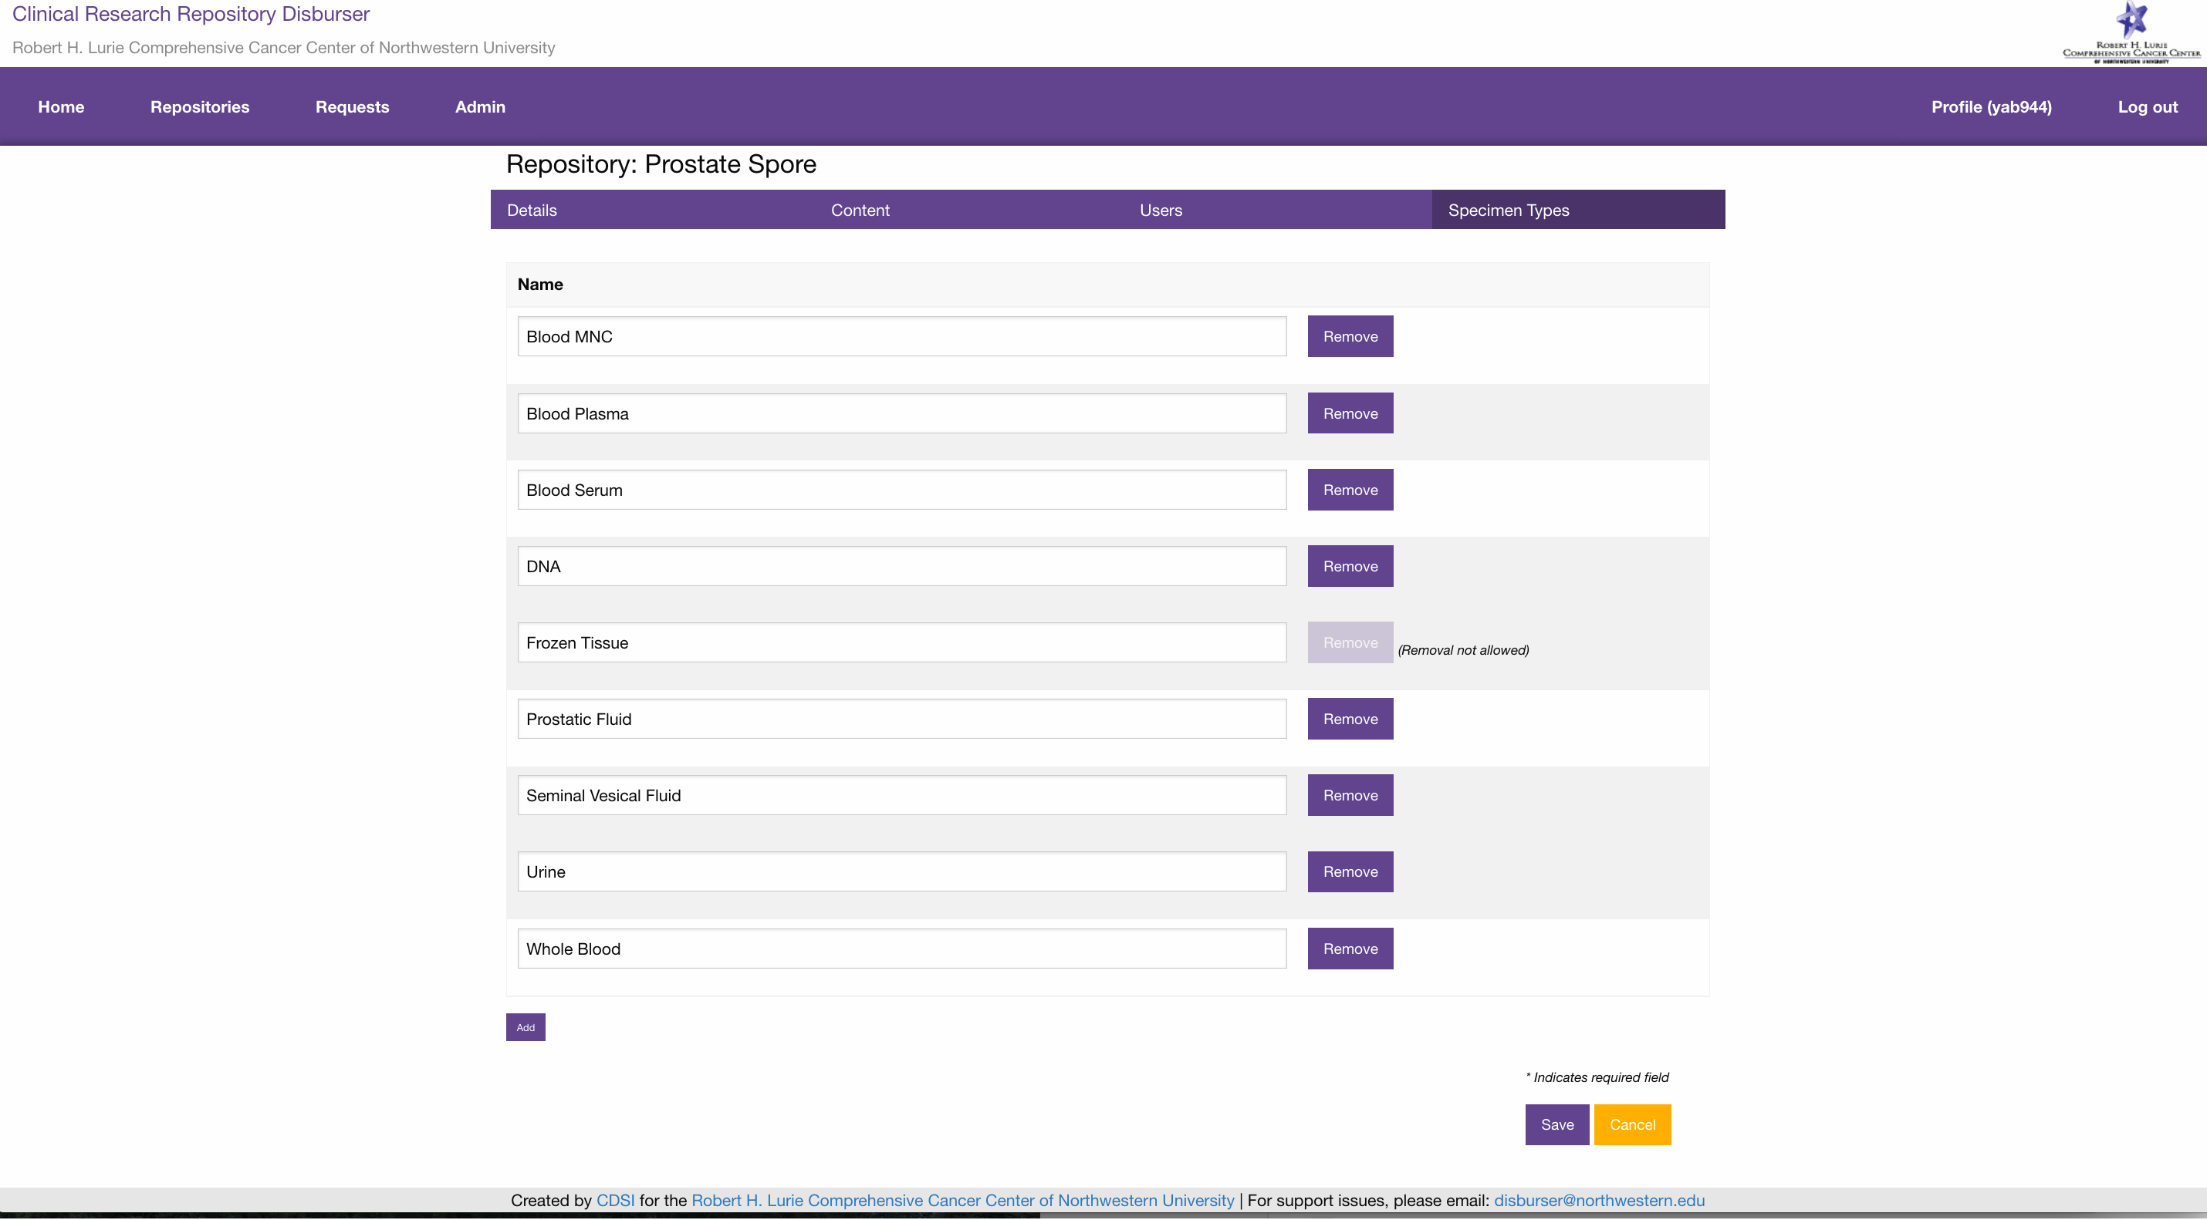

The ‘Specimen Type’ tab allows you to add, edit and remove specimen types for the biorepository. These specimen types will fill the dropdown list for making a new disbursement request to the biorepository. Once a specimen type has been selected on a disbursement request, it may not be removed.

**Biorepository administrator**: **managing disbursement requests**

Biorepository administrators are responsible for managing the ‘Status’ of disbursement requests. A biorepository administrator will have an ‘Admin’ menu item. The ‘Amin’ page lists all the disbursement requests the user is responsible for administering.

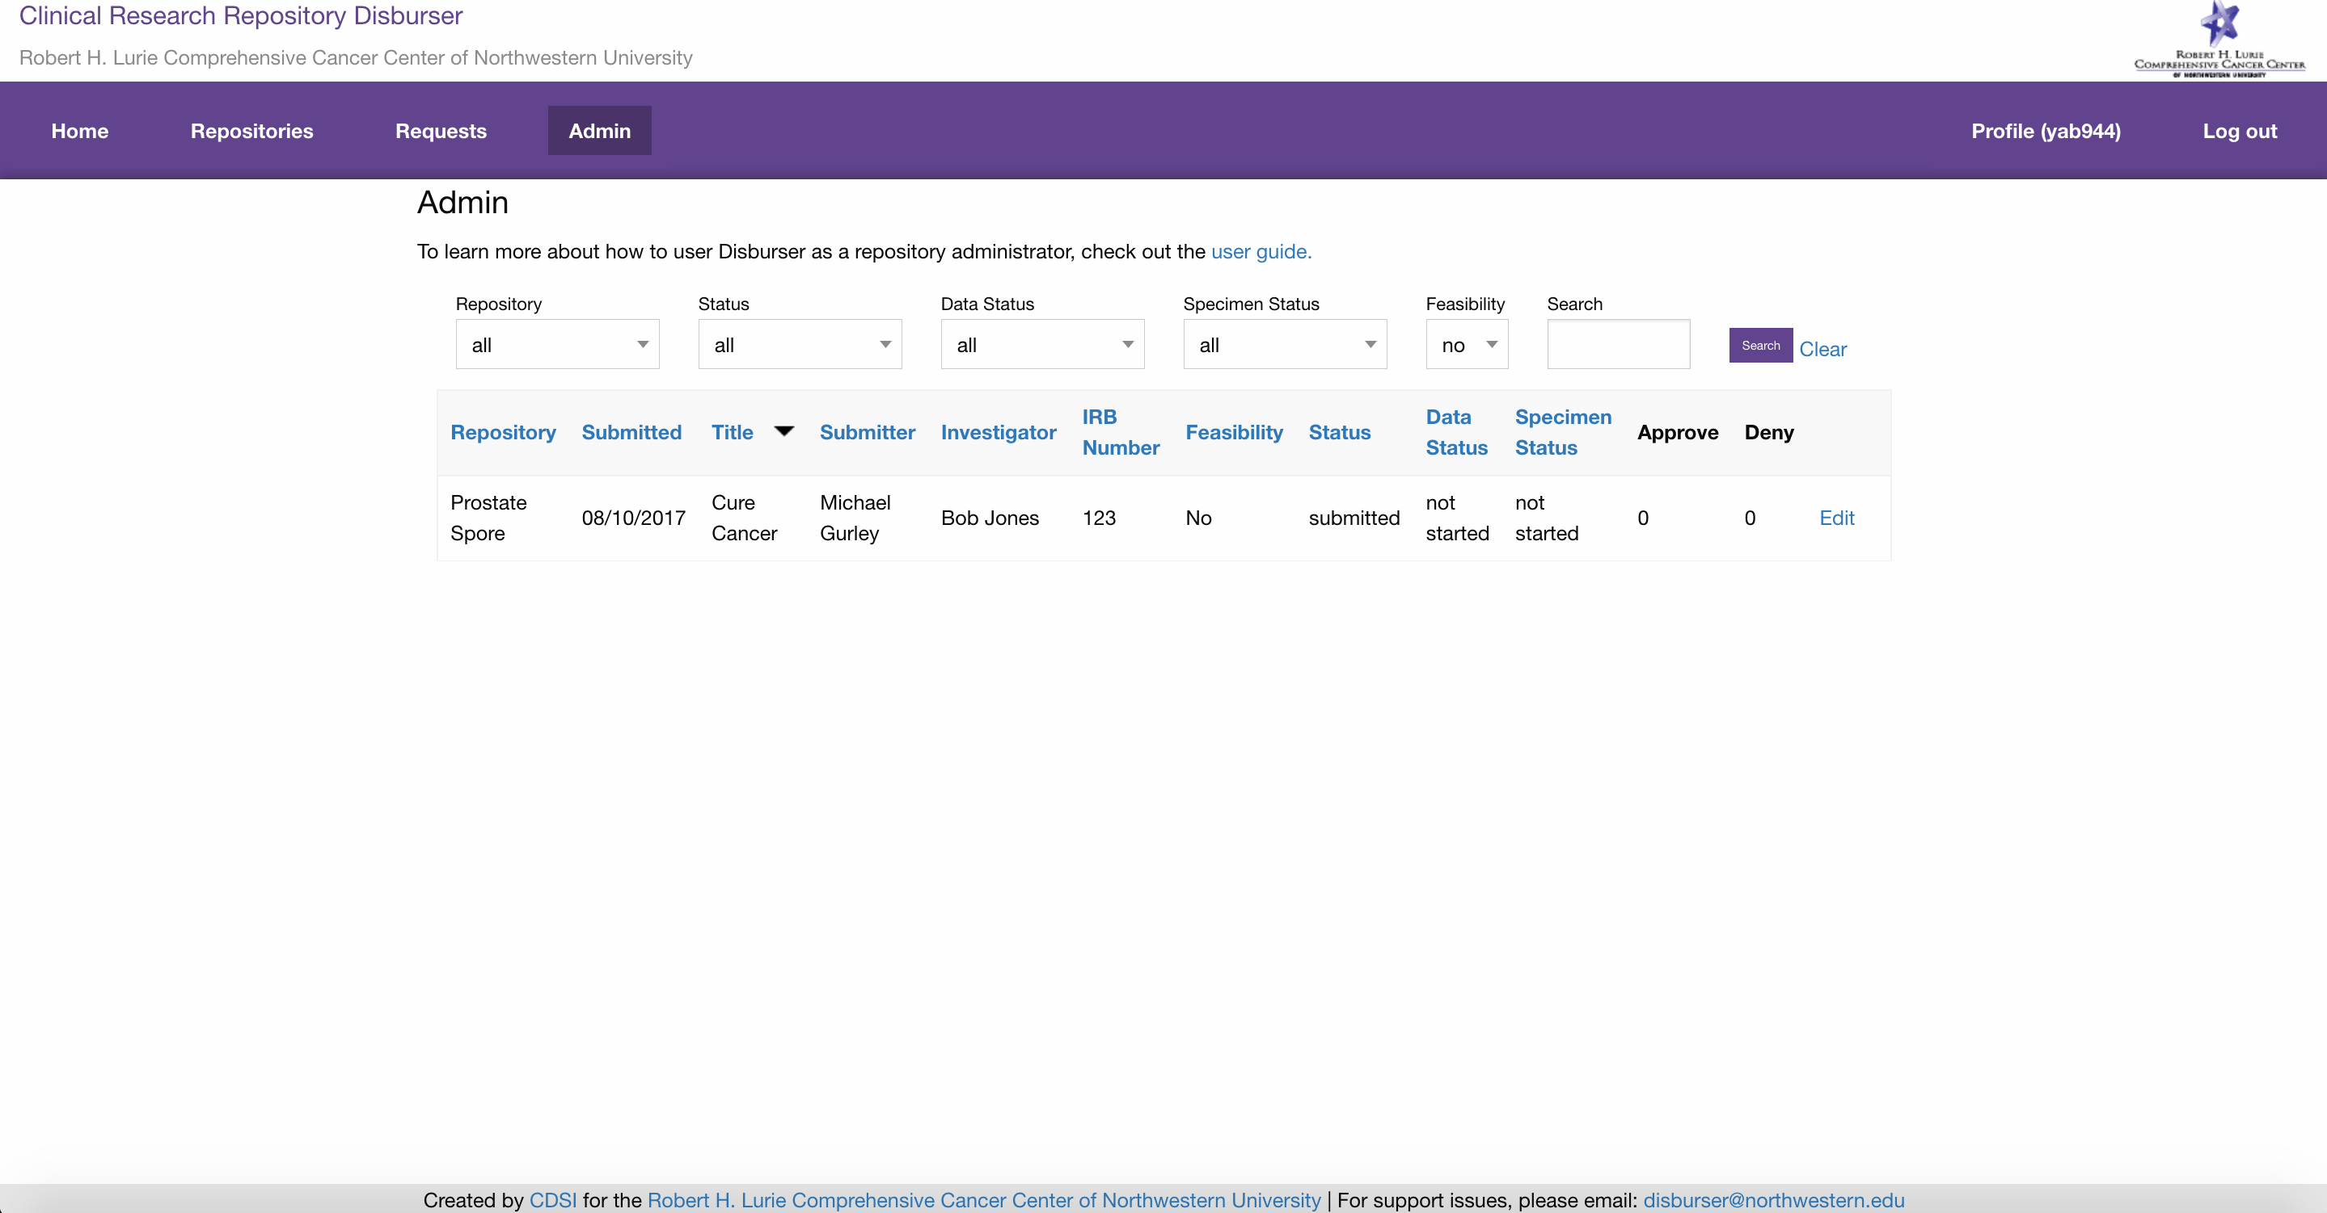

A repository administrator may filter the list of disbursement requests by ‘Repository’, ‘Status’, ‘Data Status’, ‘Specimen Status’ and ‘Feasibility’. Click the ‘Edit’ link on the disbursement request you are interested in managing.

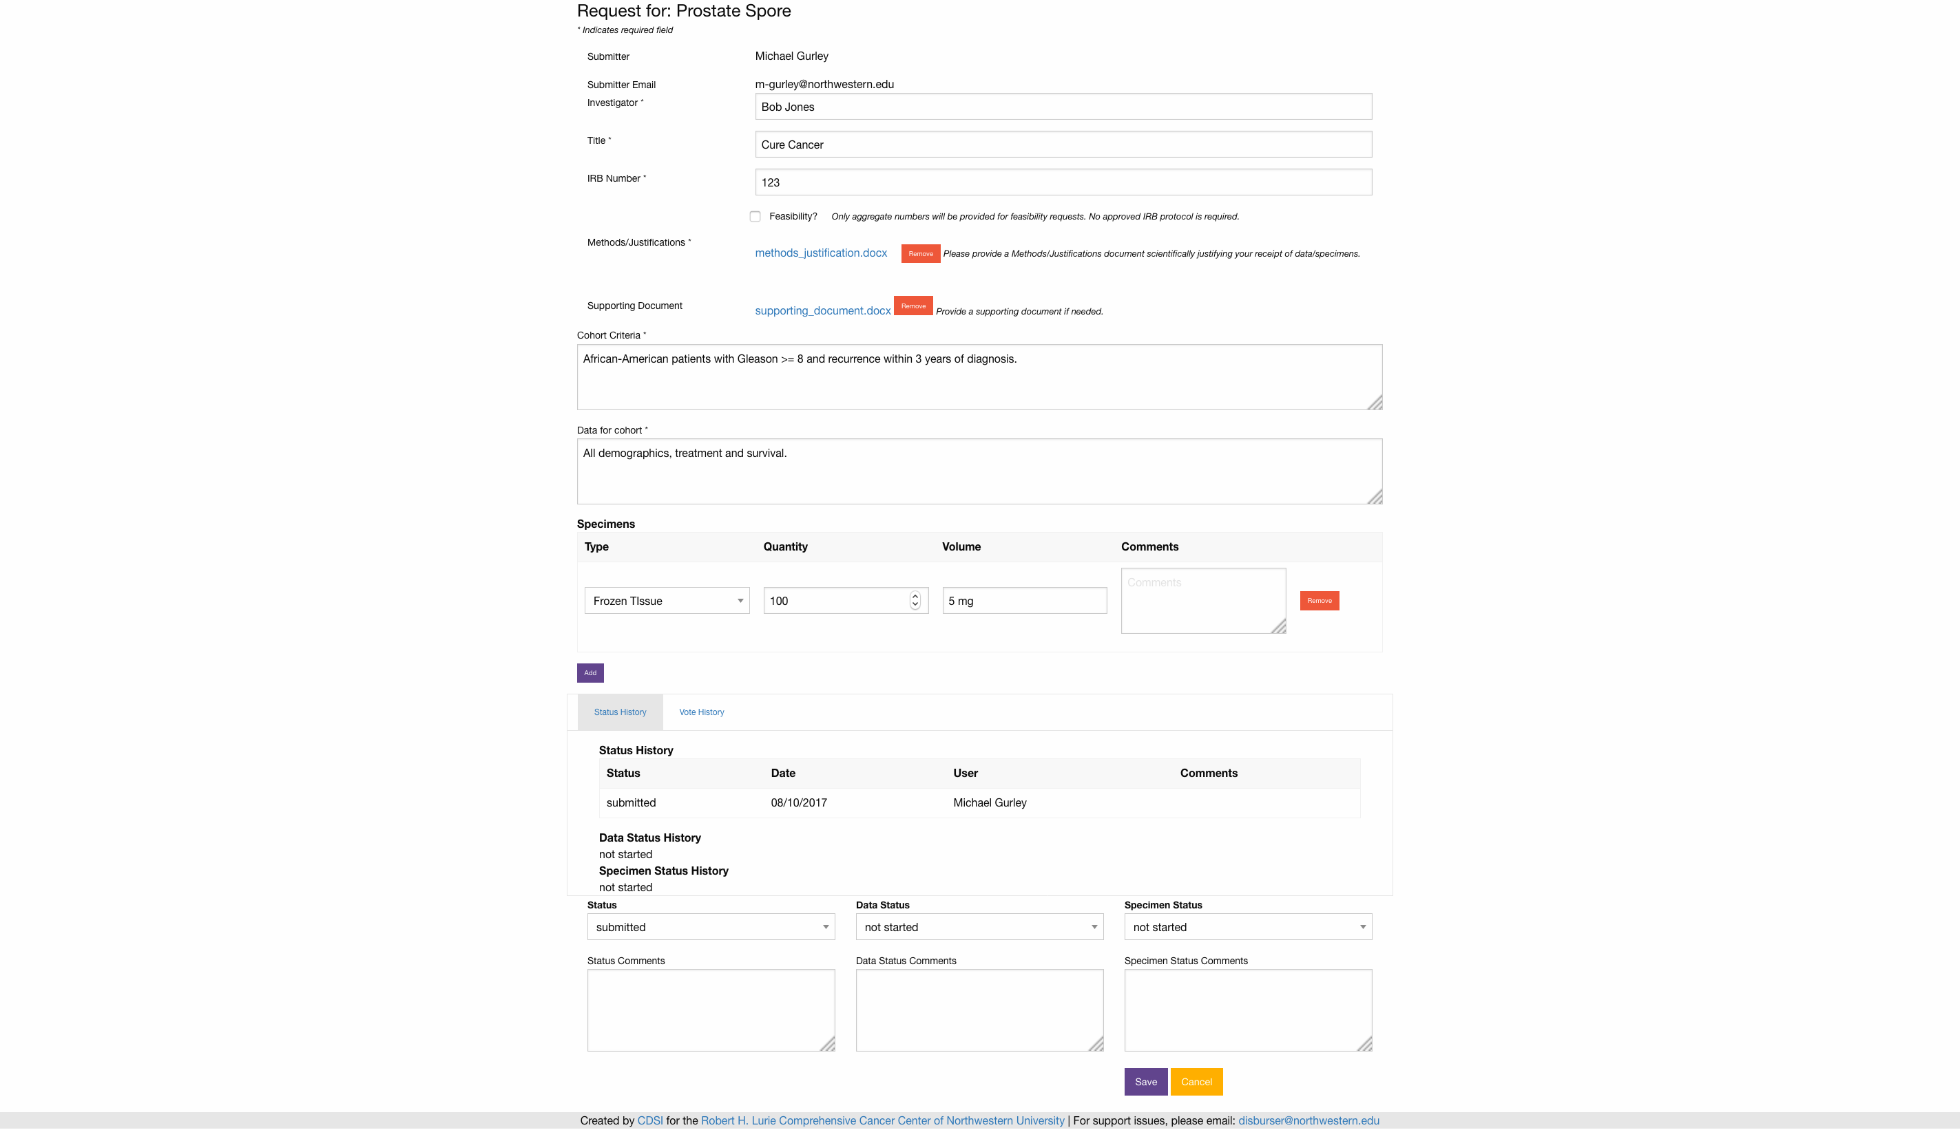

A repository administrator my edit the details of a disbursement request. However, this should only be done in consultation with the submitter/investigator. The repository administrator’s primary responsibility is managing the ‘Status’ of the disbursement request.

* ‘Status’: The overall status of the disbursement request tracks its progress from submission to approval or denial.
  + ‘Draft’: An initial state of the disbursement request. ‘Draft’ disbursement requests will not be sent to the attention of the biorepository administrators.
  + ‘Submitted’: A ‘Submitted’ disbursement request will be sent to the attention of the biorepository administrators.
  + ‘Committee Review’: Notifies the biorepository committee members to vote on the disbursement request. Committee votes will not be visible to the disbursement request submitter.
  + ‘Approved’: An ‘Approved’ disbursement request will send an email to the submitter that the disbursement request has been approved. The email will include instructions on how to work with biorepository coordinators to fulfill the disbursement request.
  + ‘Denied’: A ‘Denied’ disbursement request will send an email to the submitter that the disbursement request has been denied by the biorepository committee.
  + ‘Canceled’: A ‘Canceled’ disbursement will send an email to the submitter that a disbursement request has been canceled. A submitter may cancel their own request as long as the disbursement request has a status of ‘Draft’ or ‘Submitted’. All other statuses can only be canceled by the biorepository administrator.

The repository administrator will be notified via email upon a disbursement request reaching a “Status’ of ‘submitted’. The repository administrator should set the “Status’ to ‘committee review’ once it is appropriate for the committee members to vote on a disbursement request. This will notify via email all the committee members to vote on the disbursement request. If no specimen coordinator or data coordinator are setup for the biorepository, it is optional for the repository administrator to manage the ‘Data Status’ and ‘Specimen Status’ of disbursement requests.

**Biorepository data coordinator**: **managing disbursement requests**

Biorepository data coordinators are responsible for managing the ‘Data Status’ of disbursement requests. A biorepository data coordinator will have a ‘Data Coordinator’ menu item. The ‘Data Coordinator’ page lists all the disbursement requests the user is responsible for coordinating.

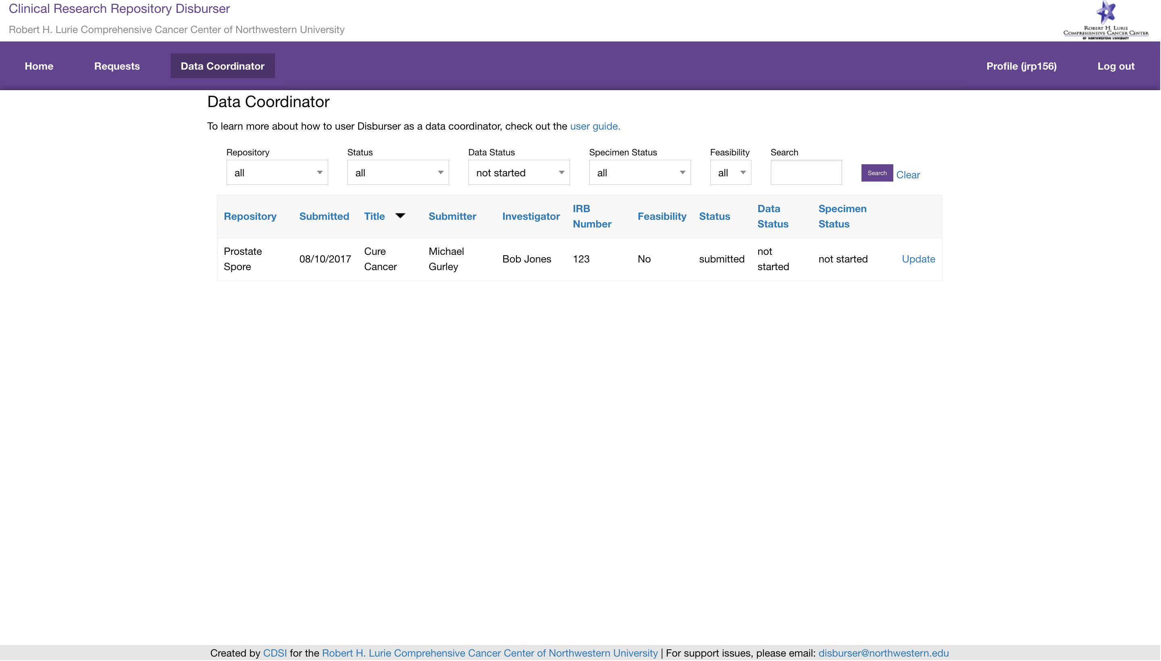

A repository data coordinator may filter the list of disbursement requests by ‘Repository’, ‘Status’, ‘Data Status’, ‘Specimen Status’ and ‘Feasibility’. By default, the page will list disbursement requests with a ‘Data Status’ of ‘not started’. Click the ‘Update’ link on the disbursement request you are interested in coordinating.



The full details of the disbursement request are available for the inspection of the biorepository data coordinator. This includes the ‘Status’ history, the ‘Data Status’ history and ‘Specimen Status’ history. A biorepository data coordinator my update the ‘Data Status’ of a disbursement request. The biorepository data coordinator may also optionally provide a comment to explain their update of the ‘Data Status’. Updating the ‘Data Status’ will cause an email notification to be sent to the submitter, repository administrators and specimen coordinators.

* ‘Data Status’: The ‘Data Status’ tracks the progress of the fulfillment of the data component of a disbursement request. At times, the fulfillment of a disbursement request’s data will be handled separately from its specimen component.
  + ‘Not Started’: The initial state of a disbursement request’s data status. ‘Not Started’ means a biorepository coordinator has not begun the process of fulfilling the data for the disbursement request.
  + ‘Data Checked: A ‘Data Checked’ data status means a biorepository coordinator has queried the requisite biorepository and the cohort criteria *can* be met. An email notification will be sent to the submitter that a disbursement request has a data status of ‘Data Checked’
  + ‘Insufficient Data’: An ‘Insufficient Data’ data status means the biorepository coordinator has queried the requisite biorepository and the cohort criteria *cannot* be met. An email notification will be sent to the submitter that a disbursement request has a data status of ‘Insufficient Data’.
  + ‘Query Fulfilled’: A ‘Query Fulfilled’ data status means the biorepository coordinator has prepared and delivered the disbursement request data to the submitter. An email notification will be sent to the submitter that a disbursement request has a data status of ‘Query Fulfilled’.

**Biorepository specimen coordinator**: **managing disbursement requests**

Biorepository specimen coordinators are responsible for managing the ‘Specimen Status’ of disbursement requests. A biorepository specimen coordinator will have a ‘Specimen Coordinator’ menu item. The ‘Specimen Coordinator’ page lists all the disbursement requests the user is responsible for coordinating.

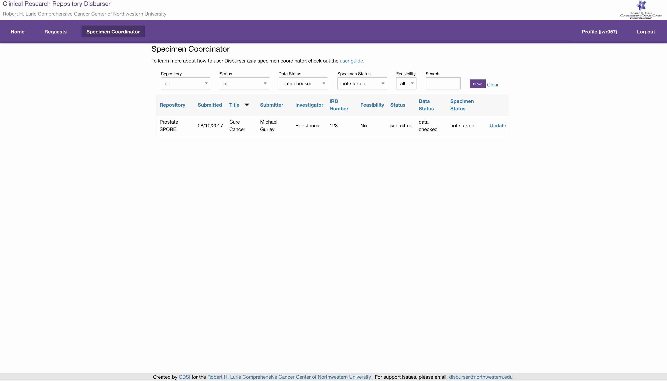

A repository specimen coordinator may filter the list of disbursement requests by ‘Repository’, ‘Status’, ‘Data Status’, ‘Specimen Status’ and ‘Feasibility’. By default, the page will list disbursement requests with a ‘Data Status’ of ‘data checked’ and a ‘Specimen Status’ of ‘not started’. Click the ‘Update’ link on the disbursement request you are interested in coordinating.

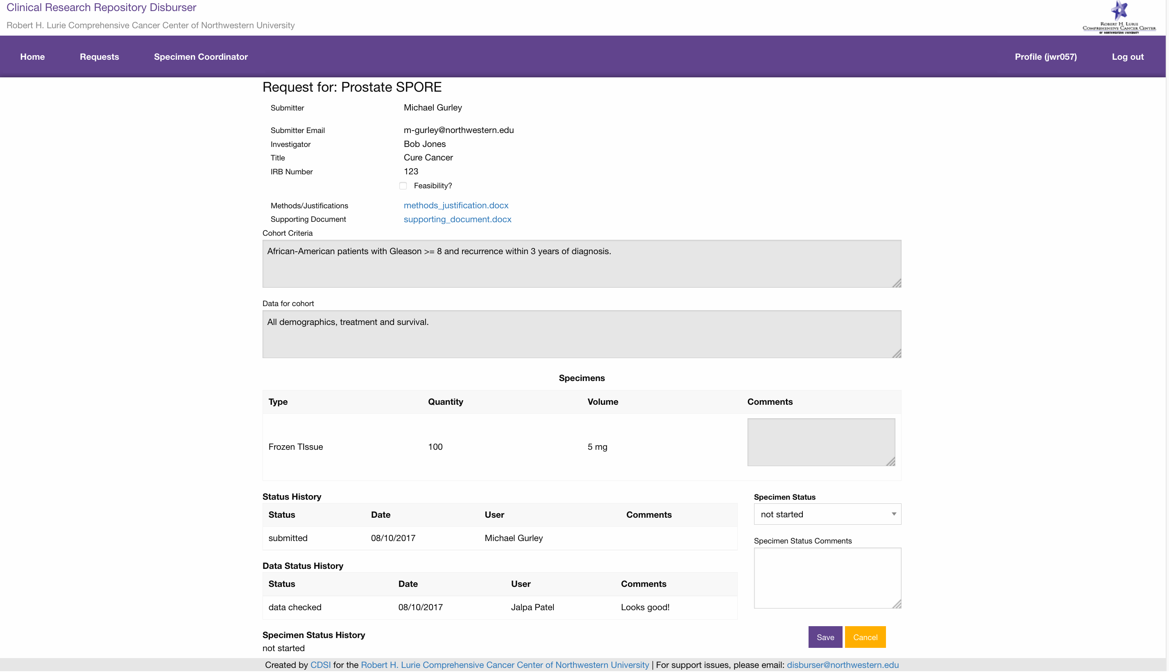

The full details of the disbursement request are available for the inspection of the biorepository specimen coordinator. This includes the ‘Status’ history, the ‘Data Status’ history and ‘Specimen Status’ history. A biorepository specimen coordinator my update the ‘Specimen Status’ of a disbursement request. The biorepository specimen coordinator may also optionally provide a comment to explain their update of the ‘Specimen Status’. Updating the ‘Specimen Status’ will cause email notification to be sent to the submitter, repository administrators and specimen coordinators.

* ‘Specimen Status’: The ‘Specimen Status’ tracks the progress of the fulfillment of the specimen component of a disbursement request. At times, the fulfillment of a disbursement request’s specimens will be handled separately from its data component.
  + ‘Not Started’: The initial state of a disbursement request’s specimen status. ‘Not Started’ means a biorepository coordinator has not begun the process of fulfilling the specimens for the disbursement request.
  + ‘Inventory Checked: An ‘Inventory Checked’ data status means a biorepository coordinator has checked the requisite biorepository specimen inventory and the disbursement request for specimens can be met. An email notification will be sent to the submitter that a disbursement request has a specimen status of ‘Inventory Checked’
  + ‘Insufficient Specimens’: An ‘Insufficient Specimens’ specimen status means a biorepository coordinator has checked the requisite biorepository specimen inventory and the disbursement request for specimens *cannot* be met. An email notification will be sent to the submitter that a disbursement request has a specimen status of ‘Insufficient Specimens’.
  + ‘Inventory Fulfilled’: An ‘Inventory Fulfilled’ specimen status means a biorepository coordinator has prepared and delivered the disbursement request specimens to the submitter. An email notification will be sent to the submitter that a disbursement request has a specimen status of ‘Inventory Fulfilled’.

**Support Issues**

Please report any problems you encounter to:

[disburser@northwestern.edu](mailto:disburser@northwestern.edu)